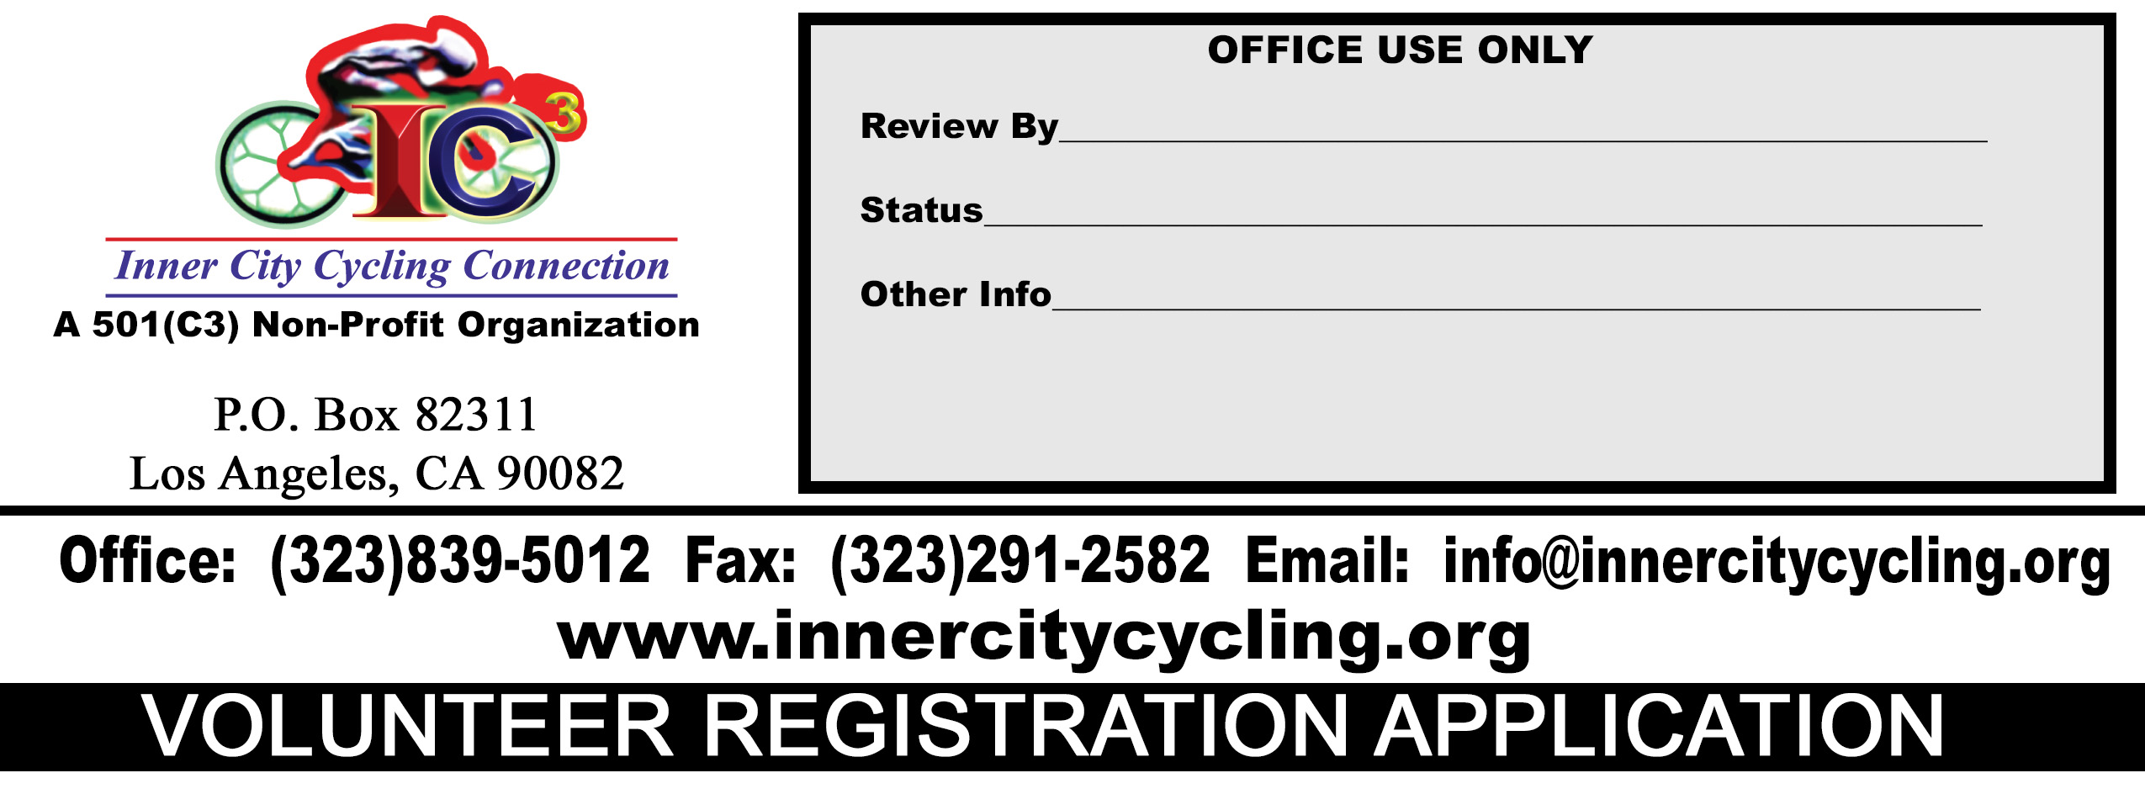
EVENT NAME_____________________________________________ DATE____________________
VOLUNTEER INFORMATION

Name

Address

City

State | Zip
Business Phone |  | Cell Phone
Email Address |  | Website Address
DESCRIPTION OF WORK TO BE PERFORMED |  | STARTING AND ENDING TIME | NUMBER OF HOURS
YOUR VOLUNTEER HOURS MIGHT BE ELIGIBLE FOR A TAX WRITE-OFF SINCE WE ARE NON-PROFIT. CONSULT WITH ONE OF OUR INNER CITY CYCLING CONNECTION, INC. REPRESENTATIVE FOR DETAILS.
****NOTICE****
I ACKNOWLEDGE THAT BY SIGNING THIS DOCUMENT, I AM ASSUMING THE RISKS ASSOCIATED WITH CYCLING, AGREEING TO INDEMNIFY, NOT TO SUE AND RELEASE FROM LIABILITY INNER CITY CYCLING CONNECTION, INC., IT’S ASSOCIATIONS, ASSOCIATES, CORPORATION BOARD OF DIRECTORS, IT’S RESPECTIVE AGENTS, EMPLOYEES, VOLUNTEERS, MEMBERS, SPONSORS, PROMOTERS, AND AFFILIATES (COLLECTIVELY “RELEASEES”), AND THAT I AM GIVING UP SUBSTANTIAL LEGAL RIGHTS. THIS ENTRY BLANK AND RELEASE IS A CONTRACT WITH LEGAL AND BINDING CONSEQUENCES AND IT APPLIES TO ALL INNER CITY CYCLING CONNECTION, INC., ACTIVITIES REGARDLESS WHETHER OR NOT LISTED ABOVE. IN ADDITION, BY SIGNING THIS DOCUMENT I UNDERSTAND AND AGREE TO THE FACT THAT INNER CITY CYCLING CONNECTION, INC. AND ITS AFFLIATES (COLLECTIVELY “RELEASEES”) ARE IN NO WAY LIABLE FOR ANY INJURIES SUSTAINED OR LOSS OF PROPERTY DURING PARTICIPATION IN ANY OF OUR EVENTS.
IN ADDITION, BY SIGNING THIS VOLUNTEER REGISTRATION FORM, I AM AGREEING TO ALL TERMS AND CONDITIONS SET FORTH WITHIN.
- ___________ (MEDIA RELEASE) I give permission for photos, video footage, and voice of the student listed in this contract taken at INNER CITY CYCLING CONNECTION, INC. and it related functions to be used for all promotional purposes (website, twitter, facebook, instagram, magazine, flyers, posters, television, radio, etc.)

ADDITIONAL COMMENTS

VOLUNTEER DATE  SIGNATURE | INNER CITY CYCLING CONNECTION, INC. TITLE DATE  REPRESENTATIVE SIGNATURE

